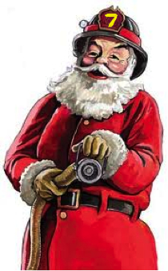
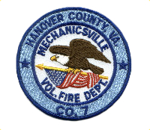
Mechanicsville Vol. Fire Department
Hanover Fire Station 7
2015 Santa Run Schedule

Monday 12/7  6:00pm – 8:30pm | Wednesday 12/9  6:00pm – 8:30pm | Saturday 12/12  4:00pm – 9:00pm
Aspen Hills  Brandy Creek  Brandy Hill Apartments  Buff Ridge  Cold Harbor Farms  Gainsmill  Lereve Manor  Lincoln Hills  Locust Hills  Travelers Run  Walnut Grove | Brooks Farm  Brooks Hollow  Covenant Woods  Cherrydale  Cherrydale West  Cypress Tree  Davis Place  Dogwood Knoll  FoxLair  Hanover Grove  Laurel Meadows  Legacy Park  Liberty Hall Hills  Meredith Farms  Summer Grove | Bell Creek  Bell Creek Estates  Chime Court  Coolwell  Green Oaks  Fullview Manor  Loralea  Meadowgate  Old Grove Glen  Ridgeview Estates  Seven Springs  Shady Brook  Shady Grove Forrest  Sherwood Crossing  Spring Meadows
Sunday 12/13  4:00pm – 9:00pm | Sunday 12/13  4:00pm – 9:00pm (continued) | Sunday 12/13  4:00pm – 9:00pm (continued)
Autumn Ridge  Barnette Oaks  Battlefield Farms  Beaverdam Bluff  Beaverdam Creek Apartments  Beaverdam Park  Berry Pointe  Brookshire  Bruces Estates  Burnside Farms  Chickahominy Bluffs  Cold Cove  Cold Harbor Gardens  Cold Harbor Meadows  Ellerson Farms | Ellerson Station  Elwin Place  Haden Estates  Harbor Square  Harbour Hill Farms  Highpoint Farms  Hunters Crossing  Hunters Woods  Jackson Avenue Apartments  Mayfield Farms  Meadowbridge  Mechanicsville Farms  Mechanicsville Heights  Mill Trace  Mill Valley | Milton Woods  Oakley  Pond Way  Rose Hill Estates  Signal Hill  Sledd Run  Summerwalk  Tangle Oaks  Thompson/Carneal  Timberlake Place  Virginia Manor  Wall Grove Court  Windmill Way  Windsor  Windy Hills  York Point

***Special Note to the Community***
Estimated times for each day are posted above and there will be two (2) Santas splitting the routes, so please be prepared.

The streets/neighborhoods listed above are not necessarily in the order we will follow each night. You should hear us coming and we’ll give a little notice, so please pardon our noise. While we perform these runs, we may, at any time, have to leave for an emergency call, so please understand that this schedule is subject to change without notice. Our tentative “make-up” date is Tuesday 12/15 and we will make every effort to get to any areas we miss.

Santa and his Elves must move swiftly so they get to see all the good boys and girls, so please understand our haste.

Since 1945, we have served our Mechanicsville neighbors 24/7.

Donations are graciously accepted.

We thank you for your tremendous support and hope you and your family will come out to see Santa Claus!

